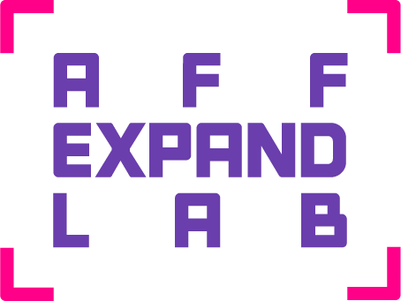

PARTICIPANTS

South Australia
Elyas Alavi |  | 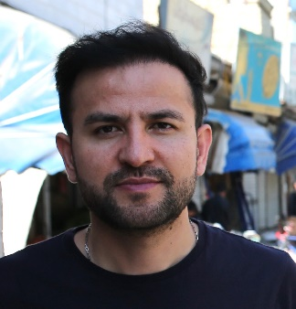
Links to work | https://www.elyasalavi.com/  https://www.instagram.com/elyasalavi/
Elyas Alavi is a visual artist and poet whose practice addresses of identity, displacement, race, religion, gender, and sexuality through painting, installation, performance and moving image. In 2007 he moved to Australia as a refugee at risk and is currently based in Tarntanya (Adelaide).

Alavi graduated from a Master of Visual Arts at the University of South Australia in 2015 and a Bachelor of Visual Arts (Honours) in 2013. He is the recipient of the 2019 Anne & Gordon Samstag International Visual Arts Scholarship, and in 2019 completed a Master of Fine Arts at Chelsea College of Arts, University of London.

Kat Bell |  | 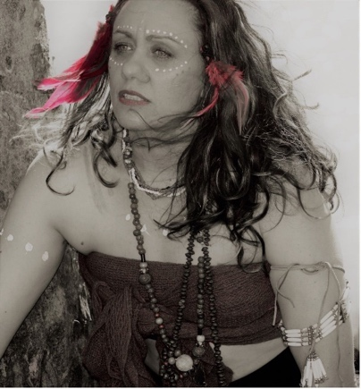
Links to work | https://www.gunduybykatbell.com/  https://www.instagram.com/katbell_gunduy
Kat Bell is a First Nation Gudjula and Girramay woman, mother, and autistic artist and writer. Through art she shares her voice, Aboriginal identity, culture, and place. A multi-media artist, Kat draws inspiration from life and the stories she encounters on her journeys across the world. Over the last few years her attentions have turned to digital arts with a particular interest in animations and projection artworks. Her most recent solo exhibition ‘Threads’ has been Kat’s most prolific body of work, addressing her long journey with trauma and PTSD. She uses her art to create narratives about her experiences living with PTSD and as a neuro-diverse Aboriginal woman navigating a neurotypical world. Kat is also known for writing poetry that accompanies her physical artworks, as extensions to the pieces of art and the stories she is sharing in the artworks. She is currently writing a fantasy novel for young people, a series of children's books, and a short story for adults. She is also working on a series of poetry books and creating small animations that build onto her diverse mediums for storytelling.

Jingwei Bu |  | 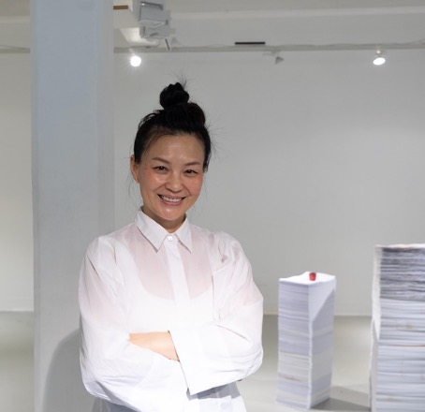
Links to work | https://www.bjwcreative.com
Jingwei Bu is an Adelaide based Chinese - Australian artist, drawing on a range of artistic traditions references both Western and Eastern cultural traditions, Bu utilises a range of modalities, from fine art to installation, art performance and performative video art, for exploring themes such as time, memory and culture heritage influenced by her Tai chi practice and Buddhist Zen learning. Her early art training in China is in the Chinese traditional technique of charcoal powder portrait drawing, later at a contemporary artist atelier in Germany and graduating with a BVA from Adelaide Central School of Art with James Martin Award for a high-achieving Bachelor of Visual Art graduate. These different learning backgrounds have been providing the technical underpinnings of her varied practice. For Bu, artmaking is an extension of everyday life, informed and inspired by all of its minor and more significant goings-on. Her thought-provoking works reflect her ongoing philosophical inquiry into the value of life and the nature of being. Bu’s meditation on issues of time, space and materiality in the context of culture and identity are a welcome salve for the world-weary spectator.

James Calvert |  | 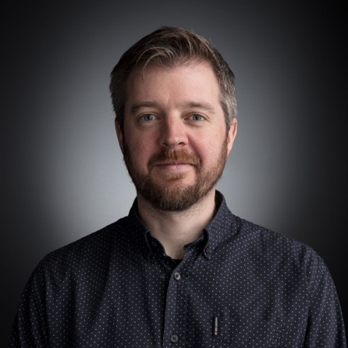
Links to work | Thin Ice VR https://www.thinicevr.com/  Carnivore Reflux (short film) https://www.youtube.com/watch?v=1Q4OKb8Fkjc
James is an educator, researcher and internationally recognised VR director, film maker and game designer. With over 20 years’ experience creating engaging content for all screen types, James has an enduring passion for immersive storytelling. James is currently a senior lecturer and research fellow at Torrens University Australia. James recently wrote and directed ‘Thin Ice VR’, a twenty-minute VR documentary that traces the steps of Sir Ernest Shackleton while at the same time highlighting the impacts of climate change on the Antarctic. The VR experience premiered at the Adelaide Film Festival and exhibited for three months at the South Australian Museum. Prior to this, James was a founder and director at the People’s Republic of Animation, where he directed short films and projects for international clients. James is also a video game designer with two successful mobile games released on the app market.

Cadence Chaos |  | 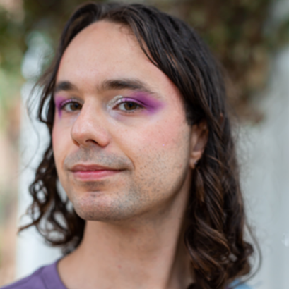
Links to work | https://cadencechaos.com
Cadence Chaos is a composer, musical theatre writer, and cabaret artist. Non-binary, neurodiverse, and chronically ill, they are drawn to the subversive and camp. During the Marriage Vote, Cadence gained a reputation as a rainbow- flag-parading polemicist for their fantasy tirade to Malcolm Turnbull. ‘Dear Malcolm Turnbull’ went viral, accruing a quarter of a million views on social media, and became an anthem for the queer community. Since then, Cadence created and performed four solo cabaret shows, won the Adelaide Theatre Guide Best Cabaret Award (2019), and four Adelaide Fringe Awards. Cadence is a graduate of the Elder Conservatorium of Music (Composition) and the Victorian College of the Arts Masters of Theatre (Writing) program.

Allison Chhorn |  | 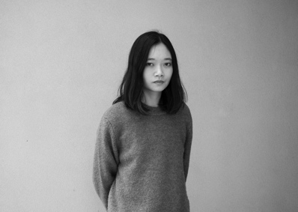
Links to work | https://allisonchhorn.com  https://vimeo.com/authoroftheaccident
Allison Chhorn is a Cambodian-Australian filmmaker and interdisciplinary artist living on Kaurna Land. Her work explores the effects of migrant displacement and post-memory through impressionistic forms, often with other family members as subjects. Since graduating with Honours in painting at UniSA in 2014, she has made numerous films including ‘Blind Body’, ‘Missing’ and ‘The Plastic House’. The latter was filmed on her family’s farm and has screened at MIFF, New York Film Festival and the Asia Pacific Triennial of Contemporary Art. Her films were also screened as part of a retrospective at the 11th Cambodian International Film Festival. Crossing into the gallery, she received the 2022 Porter St Commission from ACE Gallery to make her first solo exhibition and multi-channel installation ‘Skin Shade Night Day’.

Dave Court |  | 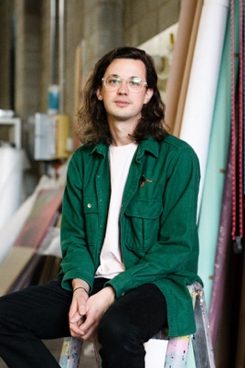
Links to work | https://www.davecourt.art/  https://www.instagram.com/dave.court/
Dave Court is a multi-disciplinary artist working in areas of painting, sculpture and installation based in Tarndanya/Adelaide, Australia. Current work includes large scale public artwork, cross media work and creation of immersive installations, all with a basis in painting. Dave has experience with a range of different projects including award winning immersive art project Mr IST, ethical clothing brand foolsandtrolls, retail store / art space Created Range, street press Yewth Magazine, and festival design with RCC and Adelaide Fringe. Dave is heavily involved with public art, as well as art direction and curation along with his ongoing studio practice. His process driven style looks at experimentation with gesture, abstraction, and oscillation between digital and physical representations.

Alex Degaris |  | 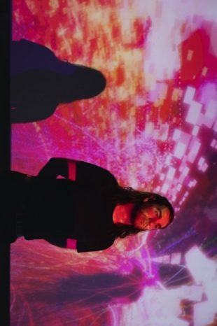
Links to work
Alex DeGaris is a digital artist based in Kaurna Yerta and currently in the final stages of studying their PhD at the University of South Australia with a focus on creative collaboration within virtual environments. DeGaris runs digital arts courses at UniSA, teaching virtual and augmented reality development for the creative arts, motion capture and creative coding. DeGaris has exhibited nationally and internationally and is currently working towards a large-scale interactive commission at the MOD scheduled for early 2023.

Kath Dooley |  | 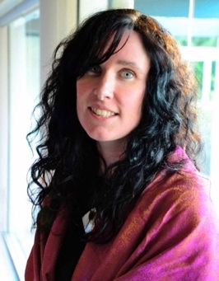
Links to work | The Sister https://vimeo.com/95459616  Inside Earthship Freo (VR) https://www.youtube.com/watch?v=YX2sc6E_1SU
Kath Dooley is a South Australian-based practitioner with a background as filmmaker, who is passionate about telling stories with VR technologies. She is also a screen production academic based at the University of South Australia. Kath’s screen practice includes a variety of work across drama and documentary genres, including award winning short films and music videos. She has also written several feature length screenplays, which reflect her interest in marginal characters. More recently, Kath has produced and directed three VR documentary works. These have screened at a variety of venues including FIVARS (Toronto), XRWA (Perth) and The Melbourne Documentary Film Festival. Kath is also author of the book Cinematic ‘Virtual Reality - A Critical Study of 21st Century Approaches and Practices’ (Palgrave Macmillan, 2021) and co-editor of ‘The Palgrave Handbook of Screen Production’ (2019).

Anthony Frith |  | 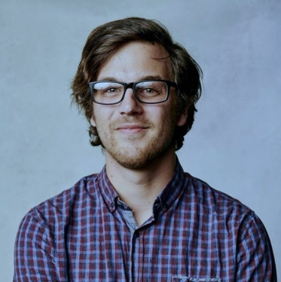
Links to work | The Mourning Show - Episode 1 Writer/Director/Editor https://youtu.be/6pL8ixsqUjI  Lessons from a Middle Class Artist - Episode 1 Writer/Director https://youtu.be/7viOVfRRhNI
Anthony Frith is a writer and director with a thirst for the absurd. His writing and directing work includes the award-winning ABC iView series LESSONS FROM A MIDDLE CLASS ARTIST. In 2018, Anthony participated in a twelve-day practical filmmaking workshop in the Peruvian jungle where he made a film under the mentorship of Werner Herzog. This led to an attachment on Werner’s NOMAD: IN THE FOOTSTEPS OF BRUCE CHATWIN. Anthony was the recipient of the 2019 AIDC’s ACCESS Mentorship grand prize which was a two-month internship at Beach House Pictures in Singapore where he worked on the story team for Discovery’s ED STAFFORD: FIRST MAN OUT. In 2022, Anthony Story Produced a new Channel 9 IP called ‘For the Love of Pets’ which is slated for TX in 2022.

Sue Kneebone |  | 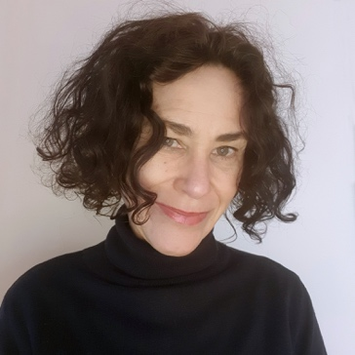
Links to work | https://suekneebone.com/  https://www.instagram.com/sue_kneebone/
Sue Kneebone’s interdisciplinary arts practice explores the environmental and social legacies related to the incursions and impacts of colonisation. Informed by field and archival research, Sue’s approach incorporates the transformative processes of assemblage and montage to create works that traverse the sinister, spectral and sublime. Her visual aesthetic seeks to destabilise historical memory as we find ways to readdress the past. Sue has a PhD in visual arts from the University of South Australia, and an MFA from the Victorian College of the Arts, Melbourne. She has exhibited since 2000 and taught across several tertiary institutions including the University of South Australia and Adelaide Central School of Art. Recent highlights have included an international residency in Mauritius and a Kochi Biennale Foundation Pepper House Residency in Kerala, India. Sue has been a recipient of Australia Council and Arts SA grants and is currently undertaking an Arts SA Fellowship. Her work is held in the collection of the Art Gallery of South Australia and private collections.

Sarah Neville |  | 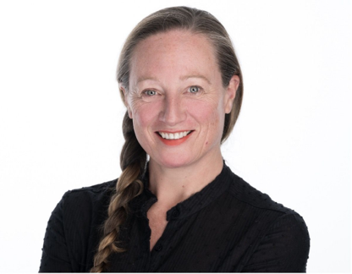
Links to work | Embodied Virtual Reality https://vimeo.com/user101177915  Spheres: A Dance for Virtual Reality https://www.sarahneville.com/virtual-reality/spheres-adance-for-virtual-reality https://vimeo.com/manage/videos/393210725
Sarah Neville is an Australian choreographer who devises new media performance, instigates inter-disciplinary practices and invests in multi-platform processes and production outcomes. Sarah has created work for Adelaide Festival and Fringe, Ausdance Choreolab, Dance House, Australian Choreographic Centre, ADT’s Ignition season, Strut Dance, Link Dance Company (WAAPA). Sarah was a member of Australian/ Spanish physical theatre company Corazon De Vaca, founder of Heliograph Productions and Kite Dance Theatre and an Artistic Associate with Open Space. Sarah’s doctorate studies are in dance digitization (Deakin University/ Coventry University). In 2021 Sarah was awarded an Arts SA Fellowship to create Dance for Virtual Reality experiences.

Claudia Nicholson |  | 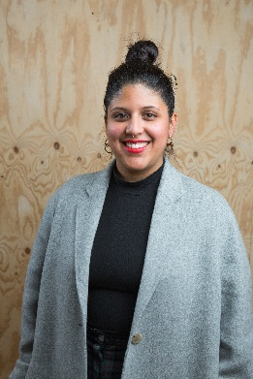
Links to work | https://claudianicholson.com/Let-Me-Down
Claudia Nicholson is an artist based on Kaurna land (Tarntanya Adelaide, South Australia). Recently her work is focussed on memory as collective and embodied. She considers how the way we remember can either work to dismantle or re-enforce colonial power structures. In 2017 Nicholson was awarded the 2017 NSW Emerging Visual Arts Fellowship. In 2019 she was commissioned by Museum of Contemporary Art and Vivid Sydney Festival to create a light installation for the facade of the MCA and presented new commissioned work, ‘By Your Side’ at the Art Gallery of NSW. Recent exhibitions include: ‘A Park is Not a Forest’, Sydney College of the Arts Gallery 2022, ‘Looking at Painting’, Casula Powerhouse 2021, ‘Belonging’ Art Gallery of NSW 2019, ‘Unfinished Business: Perspectives on art and feminism’, ACCA, Melbourne 2017, ‘The NSW Visual Arts Emerging Fellowship’, Artspace, Sydney; ‘The National; New Australian Art’, Carriageworks, Sydney, 2017.Her work is held in the collections of the Art Gallery of NSW, Artbank and Campbelltown Arts Centre. In 2023 Nicholson will present new commissioned video work for the Sydney Opera House Program Shortwave. New and existing work will be exhibited in the exhibitions Fulgora and Envoi, both part of World Pride and presented at National Art School Sydney.

Melinda Rackham |  | 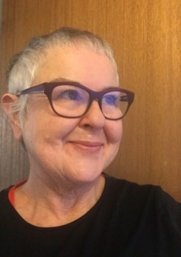
Links to work | https://subtle.net/xp&

Artist + writer Melinda Rackham lives and works on unceded Kaurna Meyunna Yerta. She/they wove tales of online intimacy, intrigue and identity in the myriad worlds of a nascent internet; creating and presenting networked, virtual reality and mobile artforms on private and prominent public screens; and founding the critically engaged global ‘-empyre-‘ forum, a platform to level up to the global north. Along with an expansive multidisciplinary practice, curational and promotional expertise, they consult, produce, assess and mentor in our creative shared communities. Recent writing explores art and artists, environment, feminisms and trauma with poetic fictions evoked, performed and inscribed into networked sites, contemporary galleries and historic buildings; while her COVID lockdown photographic parody ‘#remakemistresses’ was performed for Instagram. Their latest book ‘CoUNTess: Spoiling Illusions since 2008’, co-authored with Elvis Richardson, probes persistent gender asymmetry in the artworld through hard data, the raw immediacy of life writing and critical art theory.

Alies Sluiter |  | 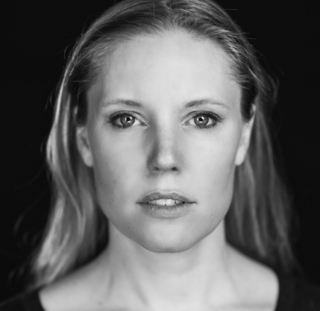
Links to work | https://vimeo.com/user4965176
Alies recently directed an episode of ‘Aftertaste’ (ABC Australia and Closer Productions) and was selected for SAFC’s 2022 Film Lab: New Voices. She is a 2020 BAFTA Newcomer, a Berlinale Talent Campus alumna and received a John Monash Scholarship to complete her MFA at Columbia University.

Her Academy Award® qualified short film AYAAN, screened worldwide, winning 20+ awards including Best Student Director from the Australian Directors Guild, Best International Short at the Show Me Shorts Festival (NZ), Best Short Film at CinefestOZ and the National Board of Review Motion Pictures Award (USA). Ayaan was also nominated for a Dendy Award, the Grand Prix at Tampere International Film Festival and an AWGIE Award. MYTH, a collaboration with Gravity & Other Myths, premiered at the 2022 Melbourne International Film Festival, where Alies was selected for the MIFF Accelerator Lab.

Prior to filmmaking, Alies worked as a violinist and AACTA nominated composer, performing in over 55 countries and collaborating with eminent artists including Nitin Sawhney, Sylvie Guillem, Sidi Larbi Cherkaoui and Akram Khan. She also musically directed Laurence Olivier Award and Time Out Critics Award (UK) nominated theatre and dance productions (‘Zero Degrees’, ‘Sacred Monsters’) and composed for many Film and TV productions.

Liam Somerville |  | 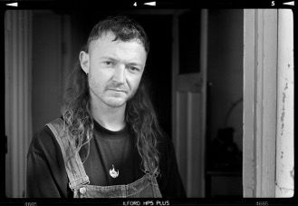  Headshot photograph by Hugh Freytag
Links to work | https://capitalwastepictures.com/ https://www.instagram.com/capitalwastepictures/
Liam Somerville is a video artist and cinematographer living and working in Tarndanya in South Australia. Liam received a Bachelor of Digital Media Arts from University of South Australia in 2010 and shortly after co-founded CAPITAL WASTE PICTURES. Over the last 12 years Liam has created and collaborated on music videos, short films, documentaries, TVCs and hundreds of hours of visual stimulation presented in cinemas, live and online. Their digital works often circulate around inputting the beautiful imperfections of the human experience into digital environments using a unique mix of technologies including optical motion capture, audio reactive coding, virtual 3D landscapes, photogrammetry and circuit bent analog glitch. This can be witnessed in their recent VR experience- ESCHATECH VR, created as part of Flinders University's ASSEMBLAGE: Artist in Residence Program (2021). Other residencies such as Cinematic Experiments with Margie Medlin at The Mill, Adelaide (2021) and Morphos Digital Dome Artist in Residence (2016) with Denver Arts +Tech Advancement in Denver, CO have all been beneficial for his continual exploration of the moving image. As a cinematographer Liam’s most recent credits include feature doco ‘The Angels: Kickin’ Down the Door’ premiering at AFF2022 and doco series- ‘VIDEO NASTY: The Making of Ribspreader’ (AFF2020).

CJ Taylor |  | 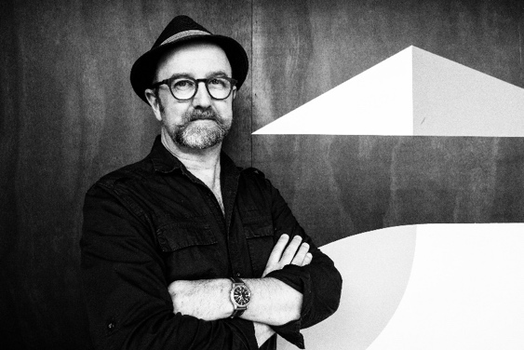
Links to work | The Hut (5/4) https://vimeo.com/216121382  https://cjtaylor.art/works
CJ Taylor’s practice engages with the concept of elastic photography in the Age of Extinction, where time collapses into a gap opened up at the edge of photomedia and cinema. The bushland where he lives on Peramangk country in southern Australia intimately shapes his practice. Experiences as a volunteer firefighter during Australian Black Summer of 2019/2020 and the climate crisis are of primary importance to his current work.

Taylor has exhibited nationally and internationally, including at the National Portrait Gallery’s Australian Photographic Portrait Prize, the Eighth Biennial CCP Documentary Photography Award, Bowness Photography Prize, Josephine Ulrick & Win Schubert Photography Award, FutureGen at FotoFreo, Whyalla Art Prize, Adelaide Parklands Art Prize, Hatched at PICA, the Pingyao International Photography Festival, China, Art Central, Hong Kong, ArtVerona and ArteFiera, Italy, the Asolo Art Film Festival and the Houston Center for Photography Texas, USA. He holds a PhD from the Australian National University. Represented by Galleria Marcolini, Italy.

Joshua Tyler |  | 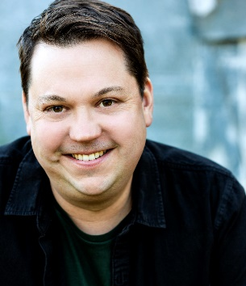  Headshot photograph by Pia Johnson
Links to work | https://www.youtube.com/watch?v=uoDBvGF9pPU  @joshuatylerpictures
Joshua co-wrote the film 'Top End Wedding' and the children’s book 'Aunty's Wedding' with Miranda Tapsell. He has been a storyteller for over twenty years. First as an actor, dancer and playwright and more recently as a screenwriter and author. ‘Top End Wedding’ premiered at the 2019 Sundance Film Festival, was distributed by Universal, became the second highest grossing Australian film of 2019 and was nominated for three AACTA awards including Best Film. 'Top End Wedding' can be found on Netflix. Joshua starred in and co-wrote two seasons of the half-hour comedy series ‘Plonk’ (Stan). He has also written for several animated series like 100% Wolf and Tashi. Joshua has worked with Australia’s top theatre and dance companies. Allen & Unwin published Joshua's first children's book 'Aunty's Wedding' in 2020. Along the way, Joshua has been running storytelling workshops and consulting with brands.

Matthew Thorne |  | 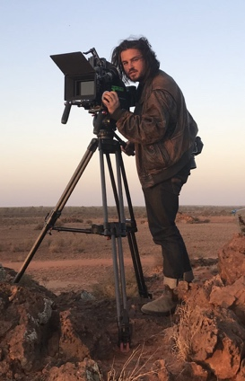
Links to work | www.matthewjjthorne.com
Matthew Thorne was born in 1993 in Adelaide, South Australia. His work combines constructed narrative storytelling and observational documentary, often drawing from the landscape of Australia and its people, to create half-real mythic stories about community, land, spirituality, and work. Matthew currently lives and works between Athens, Berlin, and Australia.

Emmaline Zanelli |  | 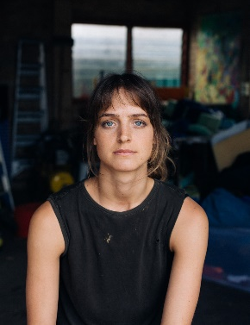  Headshot photograph by Thomas McCammon
Links to work | https://emmalinezanelli.com/projects-home-page  https://www.youtube.com/watch?v=Jr-wf-kyu-o
Emmaline Zanelli is a multidisciplinary artist based in Tarntanya/Adelaide, usually working in lens-based media. Her work uses heavily staged imagery and layered production processes to explore different possibilities of performance and sculpture made specifically for the camera. She has completed a Bachelor of Visual Art and Design at the Adelaide College of the Arts in 2015 (majoring in Photography) and a Master of Arts (Photography) at Photography Studies College in Melbourne in 2021. Her work has been exhibited in galleries nationally including Still Gallery (NSW), Perth Institute of Contemporary Art (WA), The Centre for Contemporary Photography (VIC), and the Art Gallery of South Australia. Her work has been published in the British Journal of Photography, Artlink Australia and Suddeustche Zeitung magazine. In 2022 she was selected as the winner of The Churchie Emerging Art Prize. Emmaline has been a member of South Australian performing arts collective The Bait Fridge since 2016.

National Participants
Ben Andrews |  | 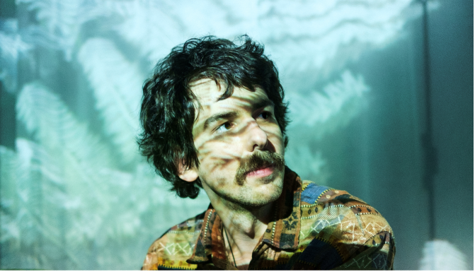
Location | VIC
Links to work | www.benjosephandrews.com  https://vimeo.com/647200798
Ben Andrews’ work integrates VR within bespoke multi-sensory environments and performance-driven installations to create collective experiences ranging from the transcendent to the ecstatic, the transformational to the sublime. His projects have been exhibited at Sundance New Frontier, SXSW, CPH:DOX, Sheffield Doc/Fest and Melbourne International Film Festival. At the heart of Andrews’ practice is the nexus between art-science, aiming to produce novel states of embodied experience that, although fleeting and transient, can momentarily expand perceptions, reawaken curiosity and instil a sense of awe and wonder to the world that surrounds and permeates us. His interest in the visceral and bodily affects of XR is supported by a practice-led PhD at the University of Melbourne, exploring the emergent framework of sensory experience and composition in virtual immersion.

Xanthe Dobbie |  | 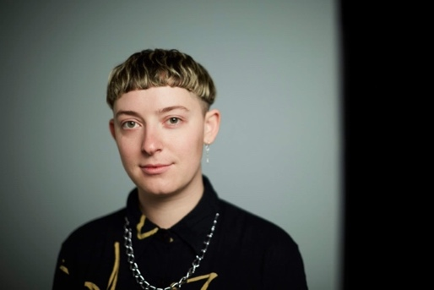
Location | VIC
Links to work | https://xanthedobbie.com/  https://www.acmi.net.au/whats-on/gallery5/the-long-now-xanthe-dobbie-online-exhibition/
Xanthe Dobbie is an artist and filmmaker. Working across on- and offline modes of making, their practice aims to capture the experience of contemporaneity as reflected through queer and feminist ideologies. Drawing on humour, pop, sex, history and iconography, they develop shrines to a post-truth era. They have exhibited extensively locally and internationally with recent works including live-streamed theatre, interactive media, AR, VR, collage, film, performance and installation. Xanthe is currently undertaking a PhD focusing on digital and interactive art at RMIT University. Xanthe lives and works between the unceded lands of the Widjabul/Wyabul people of the Bundjalung Nation and the Wurundjeri people of the Kulin Nation. Sovereignty was never ceded.

Alex Kelly |  | 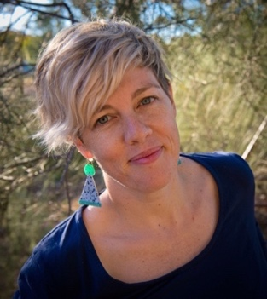  Headshot image by Anna Cadden
Location | VIC
Links to work | Twitter @aggyk  Instagram @_echotango_  Echotango.org  Unquiet.com.au
Alex Kelly (she/her) is an artist, filmmaker and activist based on Dja Dja Wurrung Country. Working across film, theatre, communications strategy and troublemaking, Alex purposefully connects the disciplines of art and change making. Alex is Impact Producer on ‘In My Blood it Runs’ and ‘The Dreamlife of Georgie Ston’e and was Global Impact & Distribution Producer on Avi Lewis & Naomi Klein’s ‘This Changes Everything’. Alex’s current focus is the speculative futuring practice ‘The Things We Did Next’, a collaborative hybrid of theatre, imagination and democracy. Alex is a founding member of ‘The Unquiet Collective’ who work with film, story and transformative change.

Eugenia Lim |  | 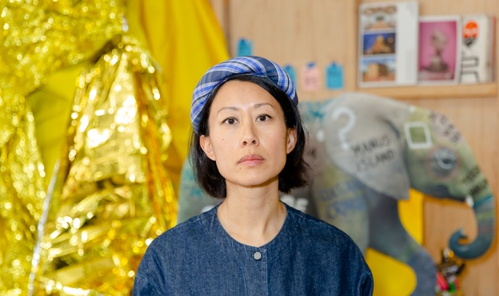Headshot image by Bryony Jackson
Location | VIC
Links to work | https://www.eugenialim.com/
Eugenia Lim is an Australian artist of Chinese-Singaporean descent who works across body, lens, social and spatial practice to explore how national identities, migration and capital cut, divide and bond our interdependent world. An ongoing strand of practice considers work, collectivity, technology and ethics – and art and capital as strange bedfellows. Often a performer within her own works, Lim invents personas to explore the tensions of the individual within society – the alienation and belonging in a globalised world. Based on unceded lands in the Kulin Nation, Lim has exhibited, screened or performed at the Tate Modern, LOOP Barcelona, FIVA (Buenos Aires), Recontemporary (Turin), Kassel Dokfest, Museum of Contemporary Art (Syd), ACCA, Next Wave, ACMI, FACT Liverpool, EXiS (Seoul) and Kunsthal Charlottenborg (DK). She has been artist-in-residence with the Experimental Television Centre (NY), Bundanon Trust, 4A Beijing Studio, Gertrude Contemporary, and she co-founded CHANNELS Festival. Lim is a 2022 Sidney Myer Creative Fellow, winner of Charlottenborg Spring’s 2022 Deep Forest Art Land Award and is a Finalist in the 67th Blake Prize. Eugenia Lim is represented by STATION.

Nathan Mewett |  | 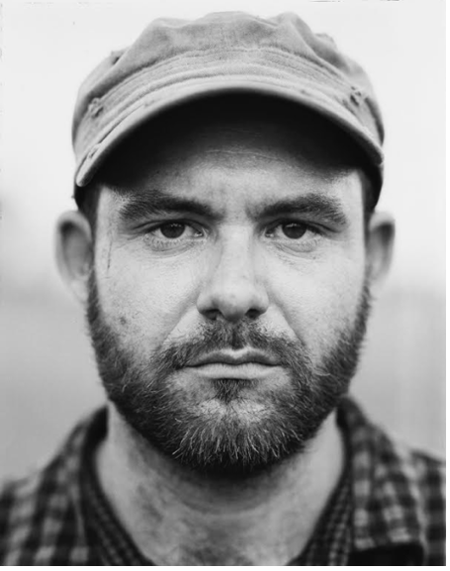
Location | WA
Links to work | https://vimeo.com/155935538
Nathan Mewett is a Western Australian filmmaker who has recently completed a slate of successful short films as Writer, Director and Producer. He is a graduate of the Masters of Screen program at AFTRS in 2018 where his exegesis investigated his co-authorship practice of developing characters of Indigenous and disabled backgrounds, building on such creative partnerships as his co-directing collaborations with Martu artist Curtis Taylor.
Nathan’s short films have played at numerous top festivals (throughout Australia and Internationally) and garnered various awards and nominations including wins for Best film at Flickerfest International Short Film Festival, ATOM Awards, Gold Coast Film Festival, Heart Of Gold Film Festival, Human Rights, Arts & Film Festival (Vic) and Qantas Vision Splendid Film Festival (Qld), Best Screenplay Award at Heart Of Gold Film Festival and a special mention for Screenplay at Sydney Film Festival. His Co-Written/ Co-Directed short film ‘Yulubidyi – Until The En’d qualified for Short Film (Live Action) presentation at the Academy Awards as well as being nominated for Short Film in the AACTA Awards.

In 2018 he was a Lexus Film Fellowship Fellow recipient and in 2017 he attended the Melbourne International Film Festivals Accelerator lab. Upon graduating from AFTRS, he received the EU Short Film Award from the Embassy of the European Union.

Archie Moore |  | 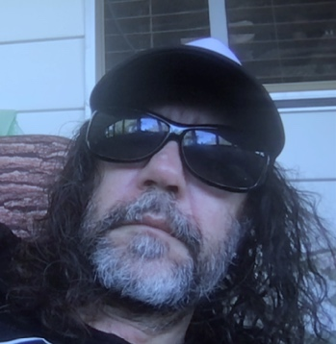
Location | QLD, Kamilaroi/Bigambul
Links to work | https://archiemoore.wordpress.com
Archie Moore works across media in portrayals of self and national histories. His ongoing interests include key signifiers of identity – skin, language, smell, home, genealogy, flags – as well as the borders of intercultural understanding and misunderstanding, including the wider concerns of racism.

Susan Norrie |  | 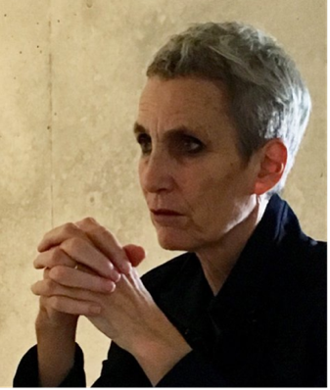
Location | NSW
Links to work | susannorrie.com
Susan Norrie has developed a practice that utilises and incorporates art history, documentary and film genres focusing on environmental and humanitarian issues. Her projects have focused on the so-called Pacific Ring of Fire: recent films have been based in Japan (2002-14) and Indonesia (2006, 2016). Norrie represented Australia at the 2007 Venice Biennale. ‘Havoc’ (a three room, multi-channel film installation) was based on the catastrophic LUSI mud volcano disaster. She returned a decade later to document the ongoing impact upon the communities and their land: ‘Aftermath’, two large scale projections, was for the Ian Potter Commission, Melbourne University, 2016. Her film ‘Transit’, selected for the 2011 Yokohama Triennale, was later acquired by the Tate Modern, London. Susan Norrie has been the recipient of numerous awards and international residencies. Recently she was the Australian Official War Artist deployed to Camp Taji, Iraq in 2016. Asa result of her projects in Japan, she was guest lecturer/ artist-in-residence at Kyoto University in 2019. The renowned volcanologist Masato Iguchi (Professor Sakurajima Volcano Research Centre, Disaster Prevention Research Institute, Kyoto University) joined her to discuss their collaborations and ongoing research interests - volcanic and seismic activity in the region; the potential of geothermal energy; and links between current scientific investigations, traditional knowledge, animism, and local shamanistic practices.

Emma Roberts |  | 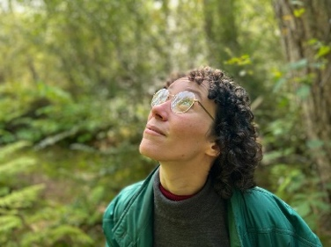
Location | VIC
Links to work | Website: www.pernicketysplit.com  Gondwana trailer : https://vimeo.com/647200798
Emma Roberts is an artist, creative producer and mischief maker working in film and virtual reality. Based on Wathaurong country in regional Victoria, her work includes some of the largest location-based VR installations in Australia, including STARLESS (2017) and allthestarstheybleedtogether (2016), both commissioned by City of Melbourne. Her durational VR piece Gondwana was selected for Sundance Film Festival, SXSW and CPH:DOX in 2022, and recently wrapped a 48-hour overnight showing at the Australian Centre for the Moving Image as part of Melbourne International Film Festival. The project won the Best Interactive/Immersive prize at the AIDC Awards and has been acquired by leading VR distributor Astrea Immersive.

She has spoken for MIT, University of West England, the Australian Centre for the Moving Image, MIFF, Sheffield Doc/Fest, Melbourne Knowledge Week and Heide Museum.

r e a |  | 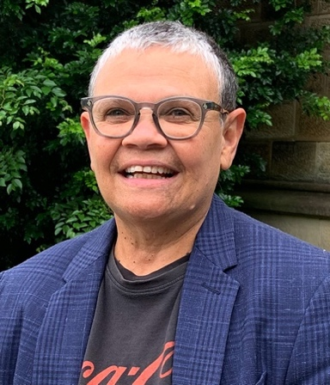
Location | NSW
Links to work | https://rea-noir.com/
r e a* is an experimental interdisciplinary artist (Indigenous Australian) / curator / activist / academic / cultural educator and creative thinker; from the Gamilaraay / Wailwan / Biripi nations located in the central western & the mid-North Coast of New South Wales. r e a’s practise-led art career takes its development from new and critical discourses, which explore intersectionality and positionality, through the cultural convergence of Aboriginality, in the creative arts and technology, history and colonialism, identity, body, gender & queer politics. r e a has been the recipient of numerous scholarships and grants throughout their professional creative and academic career, these include: a Samstag International Visual Arts Scholarship, a New Media Arts Fellowship from the Australia Council for the Arts; and a Fulbright Scholarship and she also successfully completed a B.F.A from the University of NSW; a M.A. in Visual Arts from ANU; and a M.Sc., in Digital Imaging and Design, from NYU; and Doctorate in Visual Anthropology from UNSW Art & Design.

NOTE: *r e a is the artist and author’s professional name. Due to Western and academic naming conventions, some of r e a’s writings are published as either r e a Saunders or as Dr Regina M. Saunders (Morris). r e a also uses the name “r e a noir” as a play on representations of both the colour black and its relationship to Pierre-August Renoir the French Impressionist painter.

Robert Walton |  | 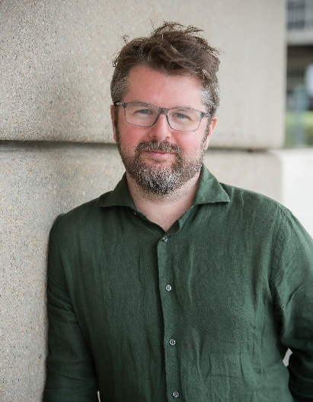
Location | VIC
Links to work | http://robertwalton.net
Robert Walton is a multi-award-winning conceptual, media and performance artist and director creating experimental multi-disciplinary experiences since 2001. Currently, he is Resident Artist in the School of Computing and Information Systems at The University of Melbourne where he leads the creation of artworks that explore the expressive potential of emerging technologies including, artificial intelligence, virtual holograms, swarm robotics, engineered bacterial bioluminescence, VR/MR/XR, building information model data, and ambient computing. His PhD from the University of Melbourne explored the use of smartphones in performances and won the Chancellor’s Prize for Excellence. His artwork ‘Vanita’s was nominated for best art and experimental app at the 2018 Webby Awards. He was the inaugural Australia Council Artist in Residence with Blast Theory in 2018. His work has been commissioned and toured in the UK, USA, and Australia. Robert is an Australian immigrant from the United Kingdom, born in England but of Welsh, Scottish and Manx ancestry living and working in Naarm (Melbourne), the unceded land of the Wurundjeri people of the Eastern Kulin Nation.

